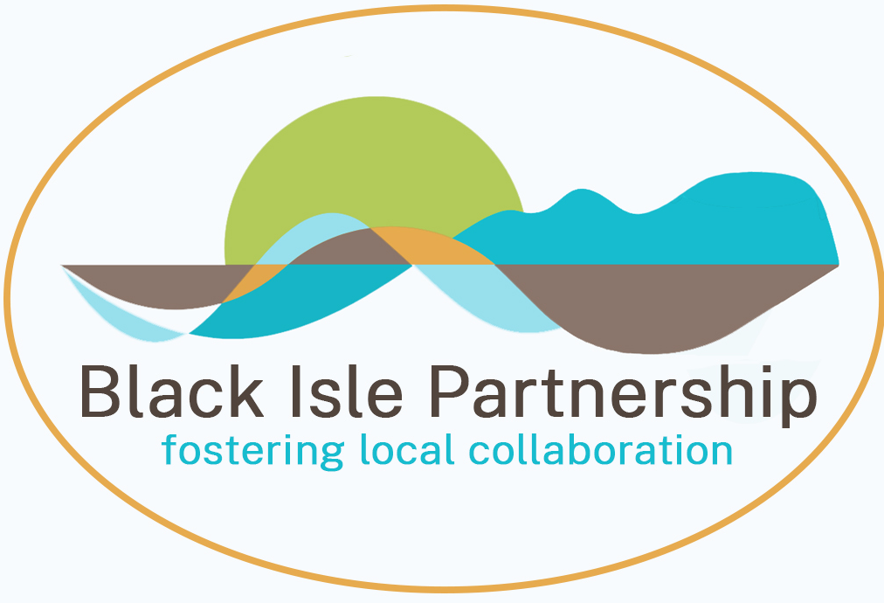

Project Coordinator – part time post for 12 months

Background

The Black Isle Partnership (BIP) was created to further the interests of residents and businesses of the Black Isle. From 2015, its primary activity was related to developing tourism on the Black Isle with the hosting of The Black Isle Tourism Team. By the end of 2019 the tourism team launched its Slow Tourism strategy with the aim of helping businesses become more resilient (less dependent on seasonal and 'passing' trade) and strengthening ties with communities. In response to the Covid pandemic in 2020, the Black Isle Partnership took on the role of a "Community Anchor Organization" for delivering the Scottish Government's Covid-19 response for communities on the Black Isle. During this period a part time coordinator was employed to work with community groups in delivering several Black Isle wide interventions in response to the pandemic. BIP also helped develop closer links between community groups and the Highland Council at this time.

The partnership is a civil society organisation and is not part of the statutory process and does not replace, or compete with the traditional democratic bodies – the community councils, the area committees of the Highland Council or the Highland Council itself. Instead, the Partnership provides a platform for the whole of the Black Isle – bringing together the views of the local community councils, local people, local employers, and those with an interest in the well-being of the area. The BIP can also act as a ‘trading arm’ for the Black Isle, enabling Black Isle wide projects and actions.

Current job opportunity

In March 2022, the Black Isle Partnership was awarded funds by the Highland Council to develop a Local Place Plan to provide a framework for future community focused development on the Black Isle. Local Place Plans are statutory documents that set out agreed development priorities; once agreed, these are more likely to be funded. A specialist contractor will be hired to undertake research and conduct consultations and develop the Plan. We are seeking a part time Project Coordinator (20-24 hours a week for 12 months) to oversee this process.

This is an important opportunity to play a central role in planning the future direction of our communities on the Black Isle, how they can respond to the challenges of the climate emergency and of rapidly rising prices, and to help set the agenda for local action over the next ten years. At its heart will be devising ways of continuing to draw on the community energy that was so apparent in the emergency response to Covid.

The Project Coordinator will be responsible to the Board of the Black Isle Partnership.
Duties will include:
- Working with the BIP Board and local community groups to ensure compliance with the aims of the Local Place Plan
- managing the tendering process to find a specialist contractor to develop the Place Plan
- liaising with the Place Plan contractor to facilitate their work, drawing their attention to local research and introducing them to local stakeholders
- developing the work of the Black Isle Tourism Team
- working on business development plans for BIP to support the outcomes of the Place Plan
- providing support to BIP partner organisations (community development trusts etc.) in their business development activities, as required
- arranging and recording Black Isle Partnership Directors’ meetings
- collating and updating information of all stakeholder organisations and community groups in the Black Isle

What we are looking for?
- someone with an enquiring mind who is happy to take on responsibilities and to work with minimal supervision.
- The post holder should be familiar with the Black Isle and should live in or close to the area
- He/she should understand the challenges it faces and have experience of community focused economic and social development
- A knowledge of social research and monitoring and evaluation techniques is highly desirable, as would understanding of local government, third sector organisations and funding sources
- Candidates should be good listeners and able to express themselves clearly and concisely on paper and in speech.
- Being a good organiser with an ability to set and meet deadlines is important, as is an ability to work flexibly, including some evenings and occasional days at weekends.
- You should be able to drive and have your own car.
- Finally, the successful candidate will be someone with a sunny personality who enjoys meeting people and wins their trust and cooperation.

Salary: £25,000 per annum (pro-rata); working hours will be 20-24 per week. Owing to the nature of the job, flexibility will be needed to account for evening work. The contract will be for 12 months, anticipated starting date July 18th 2022. Notice will be one month, either way.
This is a freelance appointment for a self-employed contractor, who will be expected to work from a home base and provide their own equipment (computer, phone etc) and car; reasonable travel and other expenses will be reimbursed.

Candidates should apply online to this address ( julian.paren@gmail.com) stating their experience relevant to the job description, and explain why they are interested in this work.

Deadline for applications is June 17th. Short listed candidates will be interviewed.

