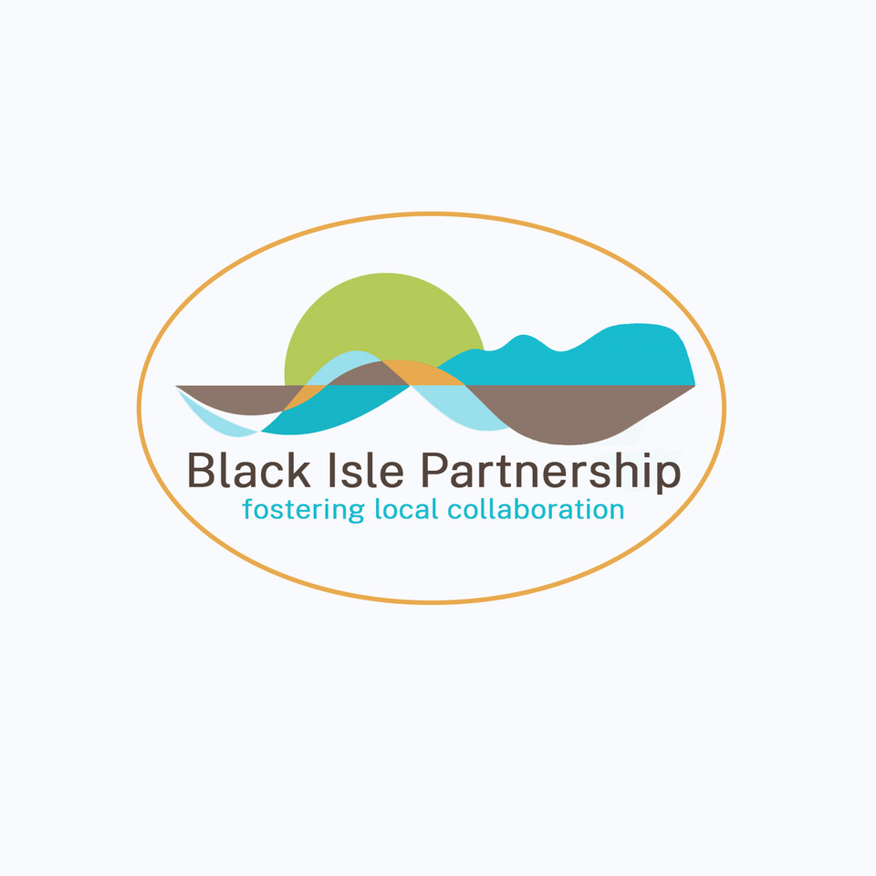
The Black Isle Partnership

Project Coordinator: part time post, initially for 12 months

The Black Isle Partnership (BIP) was created to further the interests of residents and businesses of the Black Isle. In response to the Covid pandemic in 2020, BIP took on the role of a "Community Anchor Organization" for delivering the Scottish Government’s Covid-19 response on the Black Isle.

Now BIP has been funded to develop a Local Place Plan for the Scottish Government to provide a framework for future development on the Black Isle. A specialist contractor will be hired to undertake research and conduct consultations and develop the Plan. We are seeking a part time Project Coordinator to oversee this process and to work on other BIP projects including tourism.

Salary - £25,000 pa pro rata, 2.5 – 3 days weekly to start in July.

If you are familiar with the Black Isle and live locally; have good knowledge of social research, local government, third sector organisations and community development; are well organised, able to set and meet deadlines; and enjoy meeting people, winning their trust and cooperation – we’d like to hear from you.

Please email Julian Paren at julian.paren@gmail.com for a full job description.

Short listed candidates will be interviewed

